**Lab 8**

**Lab 8-1**

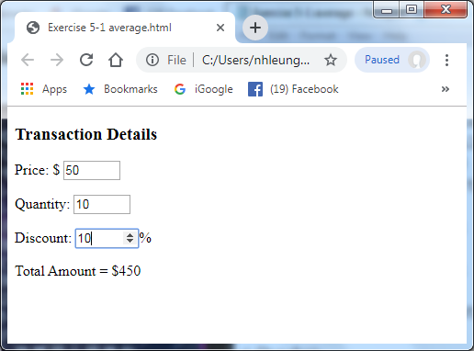Write a page to input the price, quantity and discount and then compute the Total Amount with layout similar as shown in the right.

Given Total Amount = Price x Quantity x (1-Discount/100)

**Lab 8-2**

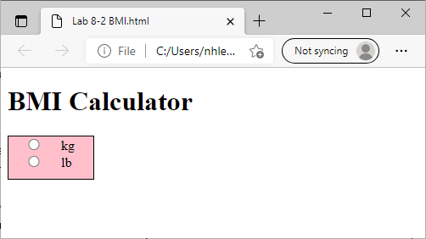By using HTML5<output> element (Example 5-2), Write a page to calculate the BMI of a person.

**Given: BMI = Weight (kg) / (Height (m) 2 )**

**1 m = 100cm**

**1 kg = 2.2 lb**

e.g. Weight = 60 kg, Height = 1.2 m , BMI = 41.6667

Weight = 100 lb, Height = 1.2 m , BMI = 31.56566

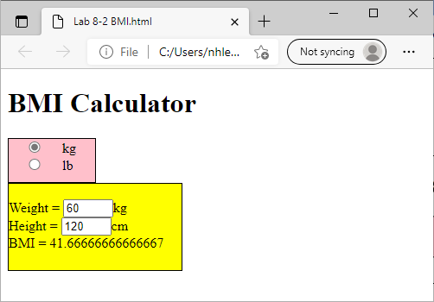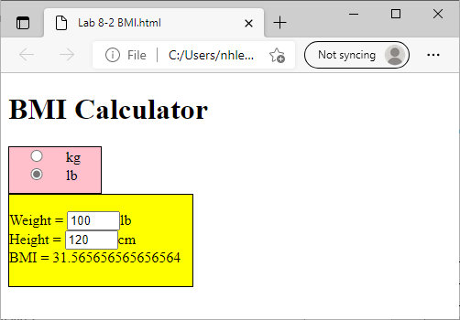

**Lab 8-3**

An HTML5 program generates the transaction screen as shown below.

Details of the screen:

1. A number box holding Price of the product.
2. A number box holding Quantity of the product purchased.
3. A slider which control the value of Quantity.
4. A datalist holding 3 different types of Delivery cost.
5. Total Amount is calculated and shown.

Remarks:

1. The range of Quantity and the slider is 1 to 10.
2. Total Amount is calculated as:

Price x Quantity + Delivery cost.

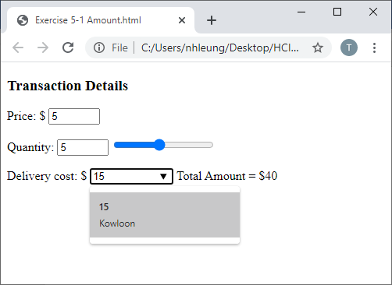

**Fig-A3**

**<body>** of the HTML5 program is shown below. Complete the missing code for the <form>.

|  |
| --- |
| <h3>Transaction Details</h3>  <form ………>  </form>  <datalist id="deliverylist">  <option label="Hong Kong" value="10"/>  <option label="Kowloon" value="15"/>  <option label="New Territories" value="20"/>  </datalist> |